APPLICATIONS OF BINARY SEARCH TREE
DSA LAB-13
P7
Following are the questions based on BST your task is to implement the questions by keeping in mind the implementation of BST in previous lab session. Complete the lab in group of two students.
EMPLOYEE REGISTERATION RECORD
Q.1.
Write a program, which will utilize the Binary Search Tree
Database is a collection of related pieces of information on Employees that is organized for easy retrieval. The data base file is shown below Record No. Id First Name Last name Weekly Salary 0 6274 John Johnson 50,000.00 1 2843 Mark Wilson 60,000.00 2 4892 Dana Albright 70,000.00 :
This information is in the file Employees.txt
6274 John Johnson 315.56 2843 Mark Wilson 7217.23 4892 Dana Albright 31462.56 8337 Debra Douglas 127.26 1892 Bruce Gold 719.32 9523 John Carlson 1496.24 3165 Mary Smith 918.26 3924 Simon Becker 485.85 6023 John Edgar 9.65 8529 Ellen Fairchild 86.77 1144 Donald Williams 4114.26
Write a client program which will do the following:
Create an Employee class class Employee implements Cloanable { private int acctID; private String firstName;
private String LastName;
private double salary;
public Employee( id, l_name,f_name,amount){….}
public int getId(){…} public String getLastName(){…}
public String getFirstName{…}
public double getSalary{…}
public void setSalary(double amount){….}
public int compareTo (Object obj) { …..}; // a method to compare if object that invokes this method is greater then, equal or less // then obj. // the method returns an integer that is less than, equal to, or greater then zero if the //executing object is less than, equal to, or greater than the parameter, respectively. }
- Create a program called Company, your program will: • Create a menu to the user with the following options:
- Read from a file the list of employees and store each employee in a Binary Search Tree, based on the employee id ( unique number)
- Add an employee to the tree
- Remove an employee from the tree
- Retrieve an employee *
- Update an employee *
- Display the firm’s employees in ascending order based on the employee id ( think of the appropriate traversal)
- Quit
*After the call to the retrieve and update operations you should display the record.
EMPLOYEE SALARY MANIPULATION

Q.2.
Suppose that you have to create a BST in which you enter the employee salary as record in the nodes of BST and then on the inserted nodes. Your task is to find the following requirements.
- Find the minimum and maximum salary from BST.
- Find the path traversal which shows the average salary of employee.

SEARCHING OF AN IMMEDIATE MANAGER
Q.3.
Write a program to arrange the given employee ID in a Binary Search Tree format and then find the immediate manager of any given employee in the organization.
Input Format
- The first line should contain the number of employees "n" to be inserted in the Tree
- The second line should contain the employee ID for which we need to find the immediate manager.
- The next "n" lines should contain the employee IDs to form the binary search Tree.

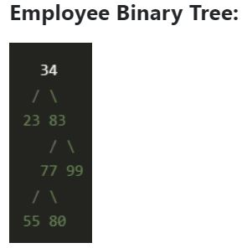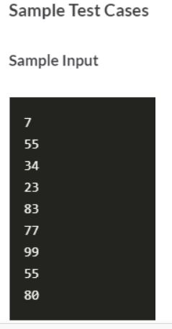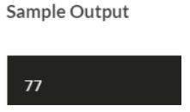

NOTE:
BONUS MARKS OF 2 will be awarded to student in graded lab-04 who would present the solutions of the questions in lab with practical code

